- Program for insert delete and edit in php
Connection.php

<?php
$server="localhost";
$user="root";
$pass="";
$dbname="phpcollection";
$conn =mysqli_connect($server,$user,$pass,$dbname);
if($conn){
echo"Connection Sucessfull";
}
else{
echo"Error in connection";
}
?>

Index.php with validation of
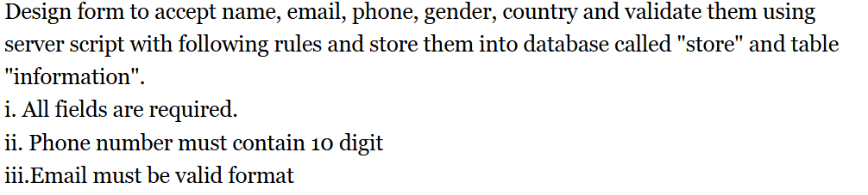

<?php
include("connection.php");
if(isset($_POST['submit'])){

//for validation

function valid($data){
$data=trim($data);
$data=stripslashes($data);
$data=htmlspecialchars($data);
return $data;
}
$name=valid($_POST['name']);
$email=valid($_POST['email']);
$phone=valid($_POST['phone']);
$gender=valid($_POST['gender']);
$country=valid($_POST['country']);

$errors=[];
// check for all field
if(empty($name)||empty($email)||empty($phone)||empty($gender)||empty($country)){
$errors[]="All fields are require";
}
// for phone number pattern

if(!preg_match("/^[0-9]{10}$/",$phone)){
$errors[]="Doesnt phone number match the pattern";
}
//for email
if(!filter_var($email,FILTER_VALIDATE_EMAIL)){
$errors[]="Doesnot match the email pattern";
}
if(!empty($errors)){
foreach($errors as $error){
echo "<p style='color:red;'>* $error</p>";
}
}
else{
$query="INSERT INTO pdetail(name,email,phone,gender,country) VALUES('$name','$email','$phone','$gender','$country')";
$data=mysqli_query($conn,$query);
if($data){
echo"Data inserted sucessfully";
}
else{
echo"Error in insertion";
}
mysqli_close($conn);
}

}
?>

<!DOCTYPE html>
<html lang="en">
<head>
<meta charset="UTF-8">
<meta name="viewport" content="width=device-width, initial-scale=1.0">
<title>Php collection</title>

<style>

body{

font-size:20px;

}
label{

margin-right: 20px;

}
input{
margin: 10px;
padding: 2px;

}
.section{
display:flex;
flex-direction:column;

}
.form-group{

margin-bottom: 20px;

}
button{
height:40px;
width: 100px;
padding: 2px;
margin: 2px;
align-items:center;

}
</style>
</head>
<body>

<form action="" method="POST">
<div class="section">
<div class="form-group">
<label for="name">Name:</label>
<input type="text" name="name" id="name" >
</div>
<div class="form-group"> <label for="email">
Email:
</label>
<input type="email" name="email" id="email" ></div>
<div class="form-group">
<label for="phone">Phone:</label>
<input type="text" name="phone" id="phone" ></div>

<div class="form-group">
<label for="gender">Gender:</label>
<input type="text" name="gender" id="gender" >
</div>

<div class="form-group">
<label for="country">Country:</label>
<input type="text" name="country" id="country" >
</div>
<button type="submit"name="submit">Submit</button>
</div>
</form>
</body>
</html>

Record.php to show records to user in table format

<?php
include("connection.php");
error_reporting(0);
$query="SELECT * FROM pdetail";
$data=mysqli_query($conn,$query);
$total=mysqli_num_rows($data);

echo("<h2> Data available is $total </h2>");

if($total!=0){

?>
<table border="1" cellspacing="0" cellpadding="10">
<th>ID</th>
<th>Name</th>
<th>Email</th>
<th>Phone</th>
<th>Gender</th>
<th>Country</th>
<th>Operation</th>
<?php
while($result=mysqli_fetch_assoc($data)){
echo "
<tr>
<td>".$result['id']."</td>
<td>".$result['name']."</td>
<td>".$result['email']."</td>
<td>".$result['phone']."</td>
<td>".$result['gender']."</td>
<td>".$result['country']."</td>
<td><a href='edit.php?id=$result[id]'>
<input type='submit' value='Edit'> </a>

<td> <a href='delete.php?id=$result[id]'>
<input type='submit' value='Delete'> </a>

</tr> ";
}
}
else{

echo 'No Record Found';
}

?>
</table>

Edit.php

<?php
include("connection.php");
$id=$_GET['id'];
$query = "SELECT * FROM pdetail WHERE id='$id'";

$data=mysqli_query($conn,$query);
$record=mysqli_fetch_assoc($data);

if(isset($_POST['submit'])){
$name=$_POST['name'];
$email=$_POST['email'];
$phone=$_POST['phone'];
$gender=$_POST['gender'];
$country=$_POST['country'];

$sql="UPDATE pdetail SET name='$name',email='$email',phone='$phone',gender='$gender',country='$country' where id='$id'";
$update_data=mysqli_query($conn,$sql);

if($update_data){
header('Location:records.php');
exist();
}

else{
die(mysqli_error($conn));
}
}

?>

<!DOCTYPE html>
<html lang="en">
<head>
<meta charset="UTF-8">
<meta name="viewport" content="width=device-width, initial-scale=1.0">
<title>Php collection</title>

<style>

body{

font-size:20px;

}
label{

margin-right: 20px;

}
input{
margin: 10px;
padding: 2px;

}
.section{
display:flex;
flex-direction:column;

}
.form-group{

margin-bottom: 20px;

}
button{
height:40px;
width: 100px;
padding: 2px;
margin: 2px;
align-items:center;

}
</style>
</head>
<body>

<form action="" method="POST">
<div class="section">
<div class="form-group">
<label for="name">Name:</label>
<input type="text" name="name" id="name" value="<?php echo $record['name'];?>" required>
</div>
<div class="form-group"> <label for="email">
Email:
</label>
<input type="email" name="email" id="email" value="<?php echo $record['email'];?>"required></div>
<div class="form-group">
<label for="phone">Phone:</label>
<input type="text" name="phone" id="phone" value="<?php echo $record['phone'];?>"required></div>

<div class="form-group">
<label for="gender">Gender:</label>
<input type="text" name="gender" id="gemder" value="<?php echo $record['gender'];?>"required>
</div>

<div class="form-group">
<label for="country">Country:</label>
<input type="text" name="country" id="country "value="<?php echo $record['country'];?>" required>
</div>
<button type="submit"name="submit">Submit</button>
</div>
</form>
</body>
</html>

Delete.php

<?php
include("connection.php");
$id= $_GET['id'] ; // getting the id from the record.php
$query="DELETE FROM pdetail where id='$id'";
$delete=mysqli_query($conn,$query);
if($delete){
echo"Record delet of id $id";
}

else{
echo"No Record found";
}
?>

SESSION HANDLING

Sessionstore.php
<?php
session_start();
if($_SERVER["REQUEST_METHOD"]=="POST"){
$_SESSION['name']=$_POST['name'];
$_SESSION['email']=$_POST['email'];
header("Location:sessiondisplay.php");
exit();
}
?>

<!DOCTYPE html>
<html lang="en">
<head>
<meta charset="UTF-8">
<meta name="viewport" content="width=device-width, initial-scale=1.0">
<title>Session</title>

</head>
<body>
<form method="POST">
<label for="name">Name:</label>
<input type="text" name="name" required id="name">
<br>
<label for="email"> Email:</label>
<input type="email" name="email" required id="email">
<br>
<Button name="submit" type="submit">
Submit
</Button>
</form>

</body>
</html>

Sessiondisplay.php

<?php

session_start();
if(!isset($_SESSION['name'])||!isset($_SESSION['email'])){
echo "No session found <a href='sessionstart.php'>Go Back</a>";
exit();
}
?>

<!DOCTYPE html>
<html lang="en">
<head>
<meta charset="UTF-8">
<meta name="viewport" content="width=device-width, initial-scale=1.0">
<title>Document</title>
</head>
<body>
<h2>Session Stored Data</h2>
<p><strong>Name:</strong> <?php echo $_SESSION['name'];?></p>
<p>Email : <?php echo $_SESSION['email'];?></p>
</body>
</html>

Cookies handling

<?php
$cookie_name="user";

if($_SERVER["REQUEST_METHOD"]=="POST"){

// code to store cookie
if(isset($_POST['save'])){
$name=$_POST['name'];
$email=$_POST['email'];

setcookie($cookie_name,$name,time() + 300);
//for email
setcookie('mail',$email,time()+ 300);
echo"Cookies has been set reload the page";

}
// code to remove the cookie
if(isset($_POST['remove'])){
setcookie($cookie_name,"",time()-300);
setcookie('mail',"",time()-300);
header("Refresh:0");
echo"Cookie is remove";

}

}

?>

<html>
<body>
<form method="POST">
Name: <input type="text" name="name" ><br>
Email: <input type="email" name="email" ><br>
<input type="submit" name="save" value="Save Cookie">
<input type="submit" name="remove" value="Remove Cookie">
</form>
<hr>
<?php
if(!isset($_COOKIE[$cookie_name])||!isset($_COOKIE['mail'])){
echo "Cookie for '".$cookie_name."' is not set. <br>";

echo "Cookie for mail is not set";

}
else{
echo "cookie of name '".$cookie_name."' is set.<br>";
echo"Cookie value".$_COOKIE[$cookie_name]. "<br>";
echo"Cookie of mail is set. <br>";
echo("Cookie value ".$_COOKIE['mail']."<br>") ;
}

?>
</body>
</html>

Why session is important for web development, write a server side script to create, store, retrieve and remove session and cookies.

<?php
session_start(); // Start the session

if (isset($_POST['submit'])) {
$name = $_POST['name'];
$email = $_POST['email'];

// ✅ Store in session
$_SESSION['name'] = $name;
$_SESSION['email'] = $email;

// ✅ Store in cookies (expire in 5 mins)
setcookie('name', $name, time() + 300);
setcookie('email', $email, time() + 300);

echo "✅ Session and Cookies are set.<br>";
}
?>

<!DOCTYPE html>
<html>
<body>
<form method="POST">
Name: <input type="text" name="name" required><br>
Email: <input type="email" name="email" required><br>
<input type="submit" name="submit" value="Set Session & Cookie">
</form>

<hr>

<h3>📦 Stored Session & Cookie Values</h3>
<?php
if (isset($_SESSION['name']) && isset($_SESSION['email'])) {
echo "Session Name: " . $_SESSION['name'] . "<br>";
echo "Session Email: " . $_SESSION['email'] . "<br>";
}

if (isset($_COOKIE['name']) && isset($_COOKIE['email'])) {
echo "Cookie Name: " . $_COOKIE['name'] . "<br>";
echo "Cookie Email: " . $_COOKIE['email'] . "<br>";
}
?>
</body>
</html>

FOR Remove

<?php
session_start();

// ✅ Remove session
session_unset(); // Remove all session variables
session_destroy(); // Destroy the session

// ✅ Remove cookies (set past time)
setcookie('name', '', time() - 3600);
setcookie('email', '', time() - 3600);

echo "🧹 Session and Cookies are removed.";
?>

- Write a server side script for implementing login. Your program should take username and password as input and redirect to home page if validated other wise prints an error try again.
Login .php
<?php
session_start();
$valid_name="Bikram";
$pass="12345";
if($_SERVER["REQUEST_METHOD"]=="POST"){
if(isset($_POST['save'])){
$name=$_POST['name'];
$password=$_POST['password'];

}
if($name==$valid_name&& $password==$pass){
$_SESSION['name']=$name;
header("Location:home.php");
}
else{
$error="Password Doesnot match";
}

}
?>

<!DOCTYPE html>
<html lang="en">
<head>
<meta charset="UTF-8">
<meta name="viewport" content="width=device-width, initial-scale=1.0">
<title>Login page</title>
</head>
<body>
<form action="" method="POST">
<h2>Login Page</h2>
<?php if(isset($error))
echo"<p style='color:red'> $error</p>";
?>
USername:<input type="text" name="name" required>
Password:<input type="password" name="password" required>
<input type="submit" name="save" value="Login">
</form>
</body>
</html>

Home.php

<?php
session_start();
if(!isset($_SESSION['name'])){
header("Location:Login.php");
}
?>
<!DOCTYPE html>
<html lang="en">
<head>
<meta charset="UTF-8">
<meta name="viewport" content="width=device-width, initial-scale=1.0">
<title>Document</title>
</head>
<body>
<h2>Welcome to home page</h2>
<p>
Welocme <?php echo $_SESSION['name'];?> !
</p>
<form action="logout.php" method="POST">
<button type="submit" name="save">Log out</button>
</form>
</body>
</html>

Logout.php

<?php
session_start();
session_unset();
session_destroy();
echo"Logout Successfully";
header("Location:login.php");
?>

- Use server-site scripting to calculate the x using the data from two text boxes.

<?php
$x="";
if(isset($_POST["add"])){
$a=$_POST['a'];
$b=$_POST['b'];
$c=$a+$b;
$x="$a + $b =$c";
}
?>
<html>
<head>
<title>
Calculator
</title>
</head>
<body>
<h1>Calculator to find the value of x</h1>
<form action="" method="POST">
A: <input type="number" name="a" placeholder="Enter the first Number">
<br><br><br>
B:<input type="number" name="b" placeholder="Enter second number">
<br> <br><br><br>

<Button name="add">Add</Button> <br><br><br>
<h3>
<?php
echo"Result :x=$x";
?>
</h3>
</form>
</body>
</html>

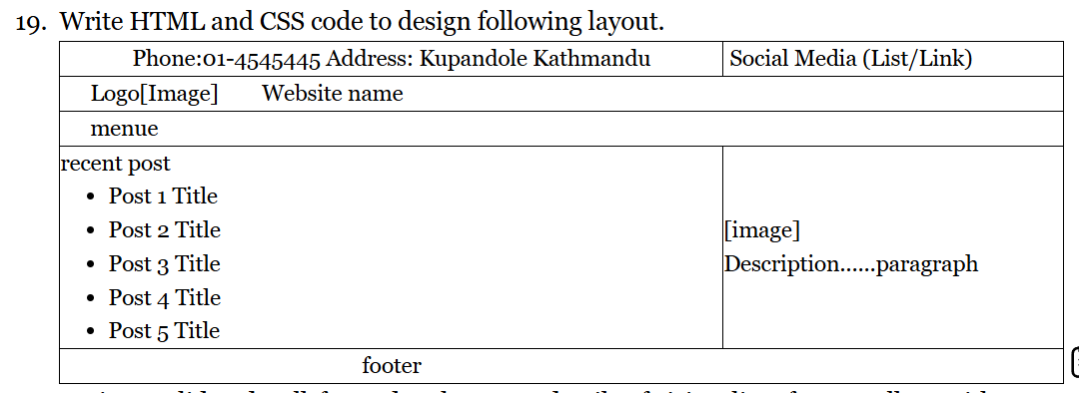

Code:
<!DOCTYPE html>
<html lang="en">
<head>
<meta charset="UTF-8" />
<meta name="viewport" content="width=device-width, initial-scale=1.0" />
<title>Frame</title>
<style>
body {
margin: 0px;
padding: 0px;
font-family: "Courier New", Courier, monospace;
color: black;
}
.top {
display: flex;
border: 1px solid black;
}
.top .left-bar,
.top .right-bar {
width: 50%;
border-left: 2px solid black;
}
/* .top-bar .left-bar:first-child {
border-left: none; /* remove extra left border
} */
.top .right-bar ul {
list-style: none;
margin: 0px;
padding: 0px;
}
.top ul li {
list-style: none;
margin-bottom: 10px;
text-align: center;
}
a {
text-decoration: none;
}
header {
display: flex;
/* align-items: center; */
border: 1px solid #ccc;
padding: 10px;
}
.logo {
width: 20%;
}
.site {
font: 24px;
}
.menu {
border: 1px solid black;
padding: 20px;
}
.container {
display: flex;
border: 1px solid black;
min-height: 100px;
}
.container .right,
.container .left {
border-left: 1px solid black;
width: 50%;
justify-content: center;
align-items: center;
padding: 20px;
}

.container .right ul li {
list-style: none;
}
footer {
border: 1px solid black;
padding: 10px;
text-align: center;
}
</style>
</head>
<body>
<div class="top">
<div class="left-bar"><p>Phone : 4489485 Address: kathmandu</p></div>
<div class="right-bar">
<ul>
<li><a href="#">Facebook</a></li>
<li><a href="#">Insta</a></li>
<li><a href="#">Tiktok</a></li>
</ul>
</div>
</div>
<header>
<div class="logo">
<img src="" alt="image" width="100px" />
</div>
<div class="site">
<a href="">Visite Site</a>
</div>
</header>
<div class="menu">Menu</div>
<div class="container">
<div class="right">
<h3>Recent Post</h3>
<ul>
<li>Post 1 Title</li>
<li>Post 1 Title</li>
<li>Post 1 Title</li>
<li>Post 1 Title</li>
</ul>
</div>
<div class="left">
<img src="" alt="Image" />
<p>This is description</p>
</div>
</div>
<footer>footer</footer>
</body>
</html>

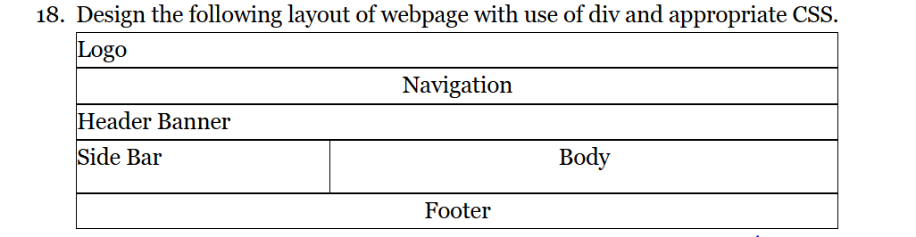

<!DOCTYPE html>
<html lang="en">
<head>
<meta charset="UTF-8" />
<meta name="viewport" content="width=device-width, initial-scale=1.0" />
<title>Document</title>
<style>
body {
font: 24px;
margin: 0px;
padding: 0px;
font-family: "Courier new , Courier ,monospace";
}
.logo {
border: 1px solid black;
padding: 10px;
}
nav {
border: 1px solid black;
text-align: center;
padding: 15px;
font: bold;
}
header {
padding: 15px;
font: bolder;
border: 1px solid black;
}
.main {
display: flex;
min-height: 100px;

border: 1px solid black;
}
.main .sidebar {
border-right: 1px solid black;
align-items: center;
width: 50%;
padding: 20px;
}
.main .body {
padding: 20px;
width: 50%;

text-align: center;
}
footer {
border: 1px solid black;
padding: 20px;

text-align: center;
}
</style>
</head>
<body>
<div class="logo">
<img src="" alt="Logo section" height="30px" />
</div>
<nav>Navigation</nav>
<header>Header Banner</header>
<div class="main">
<div class="sidebar">Side Bar</div>
<div class="body">Body</div>
</div>
<footer>Footer</footer>
</body>
</html>

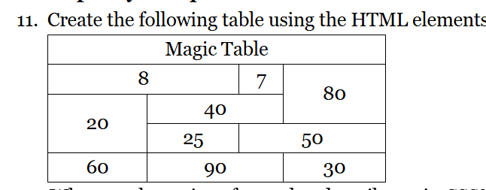

<!DOCTYPE html>
<html lang="en">
<head>
<meta charset="UTF-8" />
<meta name="viewport" content="width=device-width, initial-scale=1.0" />
<title>Document</title>
<style>
table {
border: 1px solid black;
border-collapse: collapse;
width: 300px;
text-align: center;
}
table th,
tr,
td {
border: 1px solid black;
padding: 5px;
}
</style>
</head>
<body>
<table>
<tr>
<th colspan="4">Magic table</th>
</tr>
<tr>
<td colspan="2">8</td>
<td>7</td>
<td rowspan="2">80</td>
</tr>
<tr>
<td rowspan="2">20</td>
<td colspan="2">40</td>
</tr>
<tr>
<td>25</td>
<td colspan="2">50</td>
</tr>
<tr>
<td>60</td>
<td colspan="2">90</td>
<td>30</td>
</tr>
</table>
</body>
</html>

- Create a cv using html tag only

<!DOCTYPE html>
<html lang="en">
<head>
<meta charset="UTF-8" />
<meta name="viewport" content="width=device-width, initial-scale=1.0" />
<title>Document</title>
<link
rel="stylesheet"
href="https://cdnjs.cloudflare.com/ajax/libs/font-awesome/4.7.0/css/font-awesome.min.css"
/>
</head>
<body>
<table width="1100px">
<th width="500px">
<img
src="
https://t4.ftcdn.net/jpg/05/80/60/33/360_F_580603305_ysEbDBvHCKM9TyzEINHyW614NWLdTe0b.jpg"
alt=""
border="5px,red,solid"
width="300px"
height="200px"
/>
</th>
<th width="600px" align="justify">
<h1>Your Name</h1>
<h2>Web Developer/Designer</h2>

<h4 align="justify">
<i class="fa fa-home">Your Home Location</i> <br />
<i class="fa fa-phone">Your Contact number</i> <br />
<i class="fa fa-envelope">Your Email Address</i> <br />
<i class="fa fa-laptop">Your portfolio website</i> <br />
<i class="fa fa-twitter">Your twitter Account</i> <br />
</h4>
</th>
</table>

<!-- data in the body part -->
<table width="1200px">
<th width="300px">
<h2 align="center">Profile:</h2>
</th>
<th width="700px" align="justify">
<p>
Lorem Ipsum has been the industry's standard dummy text ever since the
1500s, when an unknown printer took a galley of type and scrambled it
to make a type specimen book. It has survived not only five centuries,
but also the leap into electronic typesetting, remaining essentially
unchanged. It was popularised in the 1960s with the release of
Letraset sheets containing Lorem Ipsum passages, and more recently
with desktop publishing software like Aldus PageMaker including
versions of Lorem Ipsum.
</p>
</th>
</table>
<br />

<!-- table for skill -->

<table width="1200px" height="200px">
<th width="300px" height="50px">
<h2>Skill :</h2>
</th>
<th width="700px" height="150px" align="justify">
<h3>
I have good knowledge on differenr programming laguages such as:
<ul type="square">
<li>html</li>
<li>Java</li>
<li>Python</li>
<li>Php</li>
<li>Python</li>
<li>Php</li>
<li>Python</li>
<li>Php</li>
</ul>
</h3>
</th>
</table>
<!-- Experience Section
-->
<table width="1200px">
<th width="300px">
<h2>Experience :</h2>
</th>

<th width="700px" align="justify">
<h3>Web Designer</h3>
<h4>
Company name <br />
February 21,2025
</h4>
</th>
</table>
</body>
</html>

Output :

